Danielle Rehwoldt

HW 11 draft

**Figures:**

Could not get code to work with time I have this week, basing it off of your correct figs in pdf.

**Answer the following questions:**

1) Based on your initial random ensemble, what is the most likely additional drawdown at the town well due to pumping the ag well? How confident are you in that response - explain/defend your answer.

**The town well is located on the outer edge of the dark blue gradient where we see the drawdown effects from the ag well. Because the town is located in the dark blue area, this is a smaller effect the ag well has on the town well, around 1.5 units.**

2) What is the likelihood that the reality (represented by the meager observed data) is best represented by an MOC?

**There is a low likelihood (35.7%) because models are run with only a small number of parameters compared to real-life situations. There is only additional drawdown being looked at so if we were looking at overall drawdown, we would probably see a higher likelihood percentage as the details would matter less.**

3) What is the most likely loss in streamflow at the outflow end of the domain? Justify your answer.

**Looking at the ML streamflow along the length of the stream, we can see that the loss in the ag well versus the town well is essentially the same, but the most likely loss is the ytya (looking at ytna versus ytya).**

4) Is it likely that either the town or ag well could be contaminated by the ag field? Justify your answer.

**On the top right graph, we see that the town well has around a 50% chance of obtaining capture from the ag field as we see that light green color attaching both wells. The bottom right figure shows that the ag well has a around a 35 % likelihood that the ag well will have capture from the ag field.**

5) Make a set of plots based on ensemble 2 and discuss how each of your answers to the first four questions changed due to adding the MOC-inspired parameter sets.

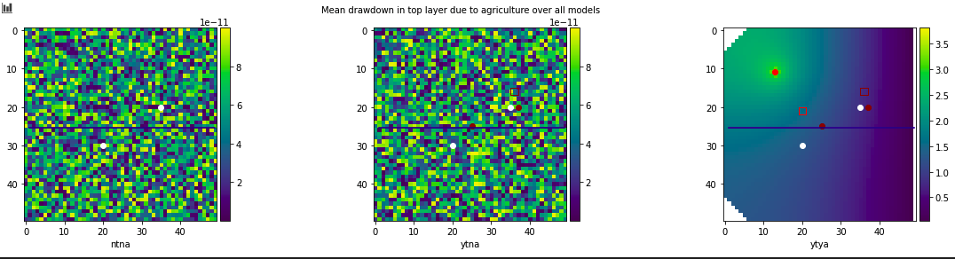*1) Based on your initial random ensemble, what is the most likely additional drawdown at the town well due to pumping the ag well? How confident are you in that response - explain/defend your answer.*

**This looks the same as the initial model.**

*2) What is the likelihood that the reality (represented by the meager observed data) is best represented by an MOC?*

**It looks like there is a 44.9% likelihood of concern. This is a 9.2 percent difference when compared to the initial model.**

*3) What is the most likely loss in streamflow at the outflow end of the domain? Justify your answer.*

**We see a larger loss in the ytya and the ytna compared to the original.**

*4) Is it likely that either the town or ag well could be contaminated by the ag field? Justify your answer.*

**These models look the same as the initial charts with a 50% likelihood ag field will affect town well and 35% chance the ag field will affect the ag well.**